**ASSIGNMENT 01 FRONT SHEET**

|  |  |  |  |
| --- | --- | --- | --- |
| **Qualification** | **BTEC Level 5 HND Diploma in Computing** | | |
| **Unit number and title** | Unit 09: Software Development Life Cycle | | |
| **Submission date** | 25/06/2022 | **Date Received 1st submission** |  |
| **Re-submission Date** |  | **Date Received 2nd submission** |  |
| **Student Name** | Bùi Hương Linh | **Student ID** | GBH200662 |
| **Class** | GCH1002 | **Assessor name** | Đỗ Tiến Thành |
| **Student declaration**  I certify that the assignment submission is entirely my own work and I fully understand the consequences of plagiarism. I understand that making a false declaration is a form of malpractice. | | | |
|  |  | **Student’s signature** | Linh |

**Grading grid**

|  |  |  |  |  |  |  |  |
| --- | --- | --- | --- | --- | --- | --- | --- |
| P1 | P2 | P3 | P4 | M1 | M2 | D1 | D2 |
|  |  |  |  |  |  |  |  |

|  |  |  |
| --- | --- | --- |
| **❒ Summative Feedback:                                                                 ❒ Resubmission Feedback:** | | |
| **Grade:** | **Assessor Signature:** | **Date:** |
| **Internal Verifier’s Comments:** | | |
| **Signature & Date:** | | |

Table of Contents

Introduction 4

Task 1 – SDLC model 4

I. Describe the following SDLC models: waterfall, v-model, prototyping, agile and spiral. Choose one that you think suitable for the project and explain why. (P1) 4

1. Waterfall 4

2. V-model 5

3. Prototyping 6

4. Agile 8

5. Spiral 9

6. Choose one that you think suitable for the project and explain why. 10

II. Discuss the suitability of each of the SDLC models for the project. For each model, specify whether it is most, moderately or least suitable. (M1) 11

III. Identify some risks and discuss an approach to manager them. (P2) 12

Task 2 – Feasibility study 13

I. Discuss the purpose of conducting a feasibility study for the project. (P3) 13

1. Definition of feasibility study. 13

2. Discuss the purpose of conducting a feasibility study for the project. 14

II. Discuss how the three feasibility criteria (technical, economic, organizational) are applied to the project. Discuss whether the project is feasible. Discuss alternative technical solutions using the alternative matrix (using alternative matrix and have some paragraphs to compare solutions). (P4) 14

1. Discuss how the three feasibility criteria are applied to the project. 14

2. Discuss whether the project is feasible. 16

3. Discuss alternative technical solutions using the alternative matrix. 16

Conclusion 17

References 18

Table 1: Compare the SDLC models (source: Internet) 11

Figure 1: Waterfall (source: Internet) 5

Figure 2: V-model (source: Internet) 6

Figure 3: Prototyping (source: Internet) 7

Figure 4: Agile (source: Internet) 8

Figure 5: Spiral (source: Internet) 10

Figure 6: Feasibility study (source: Internet) 14

# Introduction

* The Software Development Life Cycle (SDLC) is the procedure used to decide how an information system may serve business needs, design the system, construct it, and deliver it to users. It is a framework with a list of duties that must be carried out at each phase of the software development process. It is a process that ensures that all functionality, together with user requirements, goals, and final objectives, are addressed together in order to provide a comprehensive understanding of the development, design, and management of a software project. The software development process as a whole and the project quality are improved by SDLC. This could sound easy if you've taken a coding class or have written programs on your own. It is not as simple, though, in the actual world. Therefore, I shall explain in detail the significance of the SDLC in my work.

# Task 1 – SDLC model

* SDLC model:

Software development life cycle (SDLC) model describes each step of a software development project, from planning to maintenance. There are various models connected to this process, each of which has a wide range of duties and operations. (Berg, 20220)

1. Describe the following SDLC models: waterfall, v-model, prototyping, agile and spiral. Choose one that you think suitable for the project and explain why. (P1)
2. Waterfall

* Waterfall model introduced in 1970 by Winston Royce. It is a model of software development into predefined phases. Each phase must be completed before the next phase without overlap and is designed to perform specific activity within the SDLC phase. (Bhatt, 2022)

Figure 1: Waterfall (source: Internet)

* Advantages and Disadvantages

|  |  |
| --- | --- |
| Advantages | Disadvantages |
| Any changes in software is made during the process of the development. | Small changes or errors that arise in the completed software may cause a lot of problems. |
| Suited for smaller projects where requirements are well defined. | It is not desirable for complex project where requirement changes frequently. |
| Before the next phase of development, each phase must be completed. | Error can be fixed only during the phase. |
| Project is completely dependent on project team with minimum client intervention. | Clients valuable feedback cannot be included with ongoing development phase. |
| They should perform quality assurance test (Verification and Validation) before completing each stage. | Testing period comes quite late in the developmental process. |
| Elaborate documentation is done at every phase of the software’s development cycle. | Documentation occupies a lot of time of developers and testers. |

1. V-model

* The V-Model is an extension of the waterfall model and is based on the association of a testing phase for each corresponding development stage. This means that for every single phase in the development cycle, there is a directly associated testing phase. This is a very structured approach, and the start of the subsequent phase only occurs after the conclusion of the preceding phase. (Tutorialspoint, 2022)

Figure 2: V-model (source: Internet)

* Advantages and Disadvantages

|  |  |
| --- | --- |
| Advantages | Disadvantages |
| This is a highly - disciplined model and Phases are completed one at a time. | High risk and uncertainty. |
| Simple and easy to understand and use. | No working software is produced until late during the life cycle. |
| Works well for smaller projects where requirements are very well understood. | Not suitable for the projects where requirements are at a moderate to high risk of changing. |
| Easy to manage due to the rigidity of the model. Each phase has specific deliverables and a review process. | Poor model for long and ongoing projects. |
|  | Once an application is in the testing stage, it is difficult to go back and change a functionality. |
|  | Not a good model for complex and object-oriented projects. |

1. Prototyping

* A prototype is produced, tested, and then modified as necessary until an acceptable result is obtained from which the full system or product can be developed. This approach is known as the prototyping model. In situations where not all of the project needs are known in detail beforehand, this model performs best. Between the engineers and the users, it is an iterative, trial-and-error process. (Lewis, 2022)

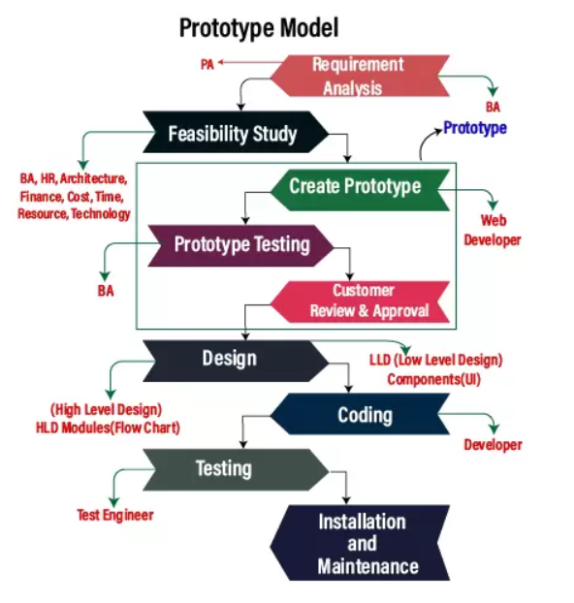

Figure 3: Prototyping (source: Internet)

* Advantages and Disadvantages

|  |  |
| --- | --- |
| Advantages | Disadvantages |
| Missing functionality and errors are detected easily. | Possibility of causing systems to be left unfinished. |
| Prototypes can be reused in future, more complicated projects. | Possibility of implementing systems before they are ready. |
| User have a better understanding of how the product works. | Not suitable for large applications. |
| Customers get a say in the product early on, increasing customer satisfaction. | Project management difficulties. |

1. Agile

* Developers created the AGILE model with the priority of the client in mind. This approach places a lot of emphasis on user input and experience. This fixes a lot of the issues with earlier software that was complicated and difficult to use. Additionally, it greatly improves the software's responsiveness to user feedback. Agile aims to swiftly release software cycles in order to adapt to a shifting market. A capable staff with great communication skills is necessary for this. By relying too much on consumer feedback, it might also result in a project veering off course. (Bhatt, 2022)

Figure 4: Agile (source: Internet)

* Advantages and Disadvantages

|  |  |
| --- | --- |
| Advantages | Disadvantages |
| Easy to manage. | There is a very high individual dependency, since there is minimum documentation generated. |
| Suitable for fixed or changing requirements. | Strict delivery management dictates the scope, functionality to be delivered, and adjustments to meet the deadlines. |
| Gives flexibility to developers. | Not suitable for handling complex dependencies. |
| Enables concurrent development and delivery within an overall planned context. | Transfer of technology to new team members may be quite challenging due to lack of documentation. |
| Good model for environments that change steadily. | An overall plan, an agile leader and agile PM practice is a must without which it will not work. |
| Little or no planning required. | Depends heavily on customer interaction, so if customer is not clear, team can be driven in the wrong direction. |
| Minimal rules, documentation easily employed. |  |
| Is a very realistic approach to software development. |  |
| Functionality can be developed rapidly and demonstrated. |  |
| Promotes teamwork and cross training. |  |
| Delivers early partial working solutions. |  |
| Resource requirements are minimum. |  |

1. Spiral

* The spiral model, which emphasizes repetition and is the most adaptable of the SDLC models, is comparable to the iterative approach in this regard. The spiral model repeatedly passes through the steps of planning, design, build, and testing, improving gradually with each iteration. (Martin, 2022)

Figure 5: Spiral (source: Internet)

* Advantages and Disadvantages

|  |  |
| --- | --- |
| Advantages | Disadvantages |
| Users see the system early. | Process is complex. |
| Allows extensive use of prototypes. | End of the project may not be known early. |
| Development can be divided into smaller parts and the risky parts can be developed earlier which helps in better risk management. | Not suitable for small or low risk projects and could be expensive for small projects. |
| Requirements can be captured more accurately. | Large number of intermediate stages requires excessive documentation. |
| Changing requirements can be accommodated. | Spiral may go on indefinitely. |
|  | Management is more complex. |

1. Choose one that you think suitable for the project and explain why.

The project of the Tune Source firm, which has an initial investment capital and a projected annual income of roughly 2 million USD, is a big-scale project that caters to a large number of clients, according to the information provided. As a result, the business must take great care when organizing and growing in order to prevent minor errors. I consider the spiral model to be the best in light of the specifications provided by the company because:

* Short term project.
* Technology is used stably.
* Have a lot of human resources and are well trained.
* Professional working environment, dynamic.

1. Discuss the suitability of each of the SDLC models for the project. For each model, specify whether it is most, moderately or least suitable. (M1)

|  |  |  |  |  |  |
| --- | --- | --- | --- | --- | --- |
| Factor | Waterfall | V-model | Prototyping | Agile | Spiral |
| Unclear user Requirement | Poor | Poor | Good | Excellent | Excellent |
| Unfamiliar technology | Poor | Poor | Excellent | Poor | Excellent |
| Complex system | Good | Good | Excellent | Poor | Excellent |
| Reliable system | Good | Good | Poor | Good | Excellent |
| Short time schedule | Poor | Poor | Good | Excellent | Poor |
| Strong project management | Excellent | Excellent | Excellent | Excellent | Excellent |
| Cost limitation | Poor | Poor | Poor | Excellent | Poor |
| Visibility of stakeholders | Good | Good | Excellent | Excellent | Excellent |
| Skills limitation | Good | Good | Poor | Poor | Poor |
| Documentation | Excellent | Excellent | Good | Poor | Good |
| Component reusability | Excellent | Excellent | Poor | Poor | Poor |

Table 1: Compare the SDLC models (source: Internet)

* In my opinion each model has its own strengths and weaknesses.

At first, waterfall is very simple and easy to use but it has to follow the flow one by one before moving on to the next stage. So waterfall is not suitable for this project.

Next, the agile model is also quite suitable for the project because it is much more flexible than waterfall.

Ultimately, spiral is the best fit for this project because short term project, technology is used stably, have a lot of human resources and are well trained, professional working environment, dynamic.

1. Identify some risks and discuss an approach to manager them. (P2)

* Definition of risk management:

Risks are unforeseeable or unplanned events that, when they occur, can wreak havoc on our future plans. In addition, it identifies potential risks, analyzes them, and takes preventive steps to limit the risks. (Tucci, 2022)

* Example:

|  |  |  |  |  |
| --- | --- | --- | --- | --- |
| Risk | Type | Probability | Impact | Solution |
| Slow progress | Quality risk | High | Medium | Together discuss and give ideas to speed up the work progress. |
| Customer can only register for a certain account to listen to sample music. | Technology risk | Very low | High | Sample music can only hear the climax of the song, not the whole song. |
| Pay a monthly fee that annoys customers. | Budget risk | High | High | Maybe charged annually or per day depending on the number of songs the customer downloads. |
| Hackers can steak existing records in a website if not well secured. | Technology risk | High | High | Website to improve security system and maintain website regularly. |
| Can crack songs and distribute them for free in the market, affecting sales. | Budget risk | Low | Low | Copyright registration. |
| The number of customers entering the store can be significantly reduced -> Because customers buy more on the web than in stores. | Quality | High | Medium | Occasionally open promotions buy 1 get 1 free, sales up to 50% … |
| Digital music is heard by many -> CDs will be forgotten. | Quantity risk | High | Medium | Encourage customers to listen to CDs to hear better quality music than digital music. |

# Task 2 – Feasibility study

1. Discuss the purpose of conducting a feasibility study for the project. (P3)
2. Definition of feasibility study.

A feasibility study is simply an assessment of the practicality of a plan or the level of expertise required for a proposed project or project method. By examining the technical, financial, and time aspects,... Additionally, it carefully and impartially assesses the advantages and disadvantages of a proposed enterprise or joint venture. export. (Simplilearn, 2022)

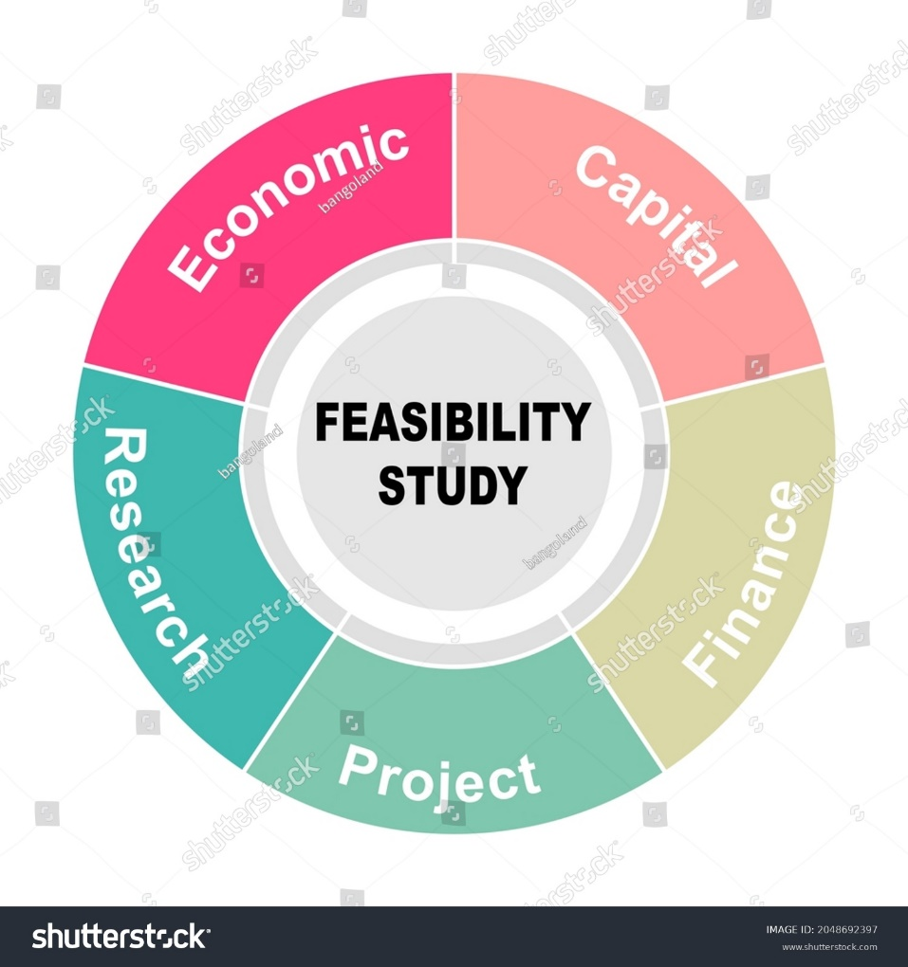

Figure 6: Feasibility study (source: Internet)

1. Discuss the purpose of conducting a feasibility study for the project.

* A feasibility study can identify the benefits and limitations of the proposed design. New discoveries from a feasibility study can completely change the goal of a project. It's better to make choices before starting a project. Because it will give the CEO and other corporate stakeholders a clear grasp of what is being proposed and a feasibility study will always benefit the Tune Source website project. Feasibility studies have many advantages, such as helping Tune Source project managers make wise choices about the amount of time and money to invest in the project. The purpose of the feasibility study is to convince the investors and the CEO if to invest in the web project.

1. Discuss how the three feasibility criteria (technical, economic, organizational) are applied to the project. Discuss whether the project is feasible. Discuss alternative technical solutions using the alternative matrix (using alternative matrix and have some paragraphs to compare solutions). (P4)
2. Discuss how the three feasibility criteria are applied to the project.

* Technical feasibility
* Familiarity with Application:

Utilizing the application won't be too challenging because the website is designed with customers in mind. How to build the functionality of a new website similar to the old website. Customers are familiar with the program, therefore using it won't be a problem for them. The new website offers a variety of features, including the ability for users to buy and sell... to satisfy the requirements of users.

* Familiarity with Technology:

Although most of the apps created are very easy to use, however, to get used to them, access them properly staff will It has to go through some training, testing and when done it will give the user the best experience and without any reason to worry about the level of risk. However, there are still many limitations but not significant.

* Project size:

It is necessary to widely advertise the website as well as products on the market and social networks, although the store system has been opened quite widely in the market because the scale of the project is not large and developed.

* Compatibility with other system:

It has high interoperability with other systems. For instance, users can pay directly by connecting a bank card to the website while making for more convenience.

* Economic feasibility
* Cash inflow

|  |  |  |  |  |  |
| --- | --- | --- | --- | --- | --- |
|  | 2021 | 2022 | 2023 | 2024 | Total |
| Download gift | $150k | $155k | $170k | $180k | $655k |
| Sell CDs right on the website | $200k | $222k | $230k | $235k | $887k |
| Customer's channel subscriptions | $850k | $899k | $999k | $1,5m | $4,248m |
| Personal music download | $520k | $666k | $777k | $888k | $2,851m |
| Total | $1,72m | $1.942m | $2,176m | $2,803m | $8,641m |

* Cash outflow

|  |  |  |  |  |  |
| --- | --- | --- | --- | --- | --- |
|  | 2021 | 2022 | 2023 | 2024 | Total |
| Hardware | $250k | 0 | 0 | 0 | $250k |
| Software | $280k | 0 | 0 | 0 | $280k |
| Equipment | $300k | 0 | 0 | 0 | $300k |
| Royalty fee | $330k | 0 | 0 | 0 | $330k |
| Labor | $420k | 0 | 0 | 0 | $420k |
| Total | $1,58m | 0 | 0 | 0 | $1,58m |

* Operation cost

|  |  |  |  |  |  |
| --- | --- | --- | --- | --- | --- |
|  | 2021 | 2022 | 2023 | 2024 | Total |
| Upgrade software | $30k | $30k | $30k | $30k | $120k |
| Software-license | $20k | $20k | $20k | $20k | $80k |
| Upgrade hardware | $40k | $40k | $40k | $40k | $160k |
| Communication fee | $10k | $10k | $10k | $10k | $40k |
| Total | $100k | $100k | $100k | $100k | $400k |

* Intangible benefit

|  |  |  |  |  |  |
| --- | --- | --- | --- | --- | --- |
|  | 2021 | 2022 | 2023 | 2024 | Total |
| Increase income | $40k | $1,842m | $2,076m | $2,703m | $6,661m |

The overall income after 4 years is projected to be between 3 and 5 percent higher, or around $8,641 million. The website will cost the business roughly $1.7 million to develop. When operational expenditures and system costs are deducted from the first year's income, we are left with roughly $40k. Since most of the first year's money is required to pay for all necessary expenses, the business will eventually recoup all of its income the following year. Operating costs are a cost that the business must incur, but they are not very high. The entire profit after 4 years will be $6,6661 million.

* Organizational feasibility

In the case study, Tune Source's executives, managers, employees, etc. have great interest in the system. They are focusing on upgrading the website to bring customers to experience many of the website's features. The less risky, user-friendly and good-looking the project is, the more the Tune Source company and especially the CEO will take care of the system. The new system with an impressive design will retain customers longer and more customers will come to Tune Source.

1. Discuss whether the project is feasible.

It is clear that Tune Source will gain a lot of advantages from the web project. However, some unforeseen problems may also arise but with the assessment of economic, technological, organizational ... and some identified risks.

1. Discuss alternative technical solutions using the alternative matrix.

|  |  |  |  |  |  |  |  |
| --- | --- | --- | --- | --- | --- | --- | --- |
|  |  | Alternative 1: Solution 1 – Custom Application using java | | Alternative 1: Solution 2 – Custom Application using C# | | Alternative 1: Solution 3 –Packaged Application using PHP | |
| Evaluation Criteria | Importance  (Weigh score) | Score (1-5) | Weighted scored | Score | Weighted scored | Score | Weighted scored |
| **Technical issue** |  |  |  |  |  |  |  |
| Supported to multiple platform | 10 | 4 | 40 | 3.5 | 35 | 3 | 30 |
| Security | 20 | 3 | 50 | 3.5 | 35 | 3 | 30 |
| Clear and friendly interface | 10 | 5 | 70 | 3 | 35 | 4 | 40 |
| Integrated with other system | 10 | 3 | 30 | 3 | 30 | 3 | 30 |
| Front-end and back-end support | 10 | 5 | 70 | 6 | 60 | 5 | 50 |
| **Economic issue** |  |  |  |  |  |  |  |
| Cost for development | 10 | 4 | 70 | 5 | 60 | 3 | 70 |
| Profit gained | 10 | 5 | 100 | 4 | 80 | 4.5 | 85 |
| Cost for license | 10 | 3.5 | 35 | 4 | 45 | 4.5 | 50 |
| **Organizational issue** |  |  |  |  |  |  |  |
| User satisfaction | 50 | 4.5 | 60 | 3 | 45 | 4 | 50 |
| Interface customization | 10 | 4 | 50 | 4 | 45 | 3 | 40 |
| Total | 150 |  | 575 |  | 470 |  | 475 |

# Conclusion

After what I learned above, I have learned a lot of valuable experiences and lessons. The exercise helped me understand more about what SDLC is and its models as well as understand more about the feasibility of the project. Although there are many problems in the article that I don't quite understand, but I still find a way to solve it effectively.

# References

Berg, M., 20220. *What Does Software Development Life Cycle (SDLC) Mean?.* [Online]   
Available at: https://www.techopedia.com/definition/22193/software-development-life-cycle-sdlc

Bhatt, J., 2022. *The SDLC Models & Methodologies: Agile, Scrum, Waterfall.* [Online]   
Available at: https://www.finoit.com/blog/sdlc-models-methodologies/?fbclid=IwAR1hYxiZlt4F87PcOx1z0H55c60LEACHfo3rDDN5Vt-8CEIoB7KPPb-1l6Q

Lewis, S., 2022. *Prototyping Model.* [Online]   
Available at: https://www.techtarget.com/searchcio/definition/Prototyping-Model?fbclid=IwAR3BiM2nu02i_UUxd2JHq8LjNgkH6D6YH3CzGQBALGKtUSljRQa3szGFntU#:~:text=The%20prototyping%20model%20is%20a

Martin, M., 2022. *Spiral Model: When to Use? Advantages and Disadvantages.* [Online]   
Available at: https://www.guru99.com/what-is-spiral-model-when-to-use-advantages-disadvantages.html?fbclid=IwAR2aW2rKzj_Kdur41t3Kv1Mnw5IZQ-hKJyR-KdgJqp2J62pZhLCgOy_nNpk

Simplilearn, 2022. *Feasibility Study and Its Importance in Project Management.* [Online]   
Available at: https://www.simplilearn.com/feasibility-study-article?fbclid=IwAR1DrcRM8ariv6Gr5oFLHOAUTetN2HhzMdAGujzv6AFXYDLVrqA-7SXDQKc#GoTop

Tucci, L., 2022. *What is risk management and why is it important?.* [Online]   
Available at: https://www.techtarget.com/searchsecurity/definition/What-is-risk-management-and-why-is-it-important?fbclid=IwAR2aW2rKzj_Kdur41t3Kv1Mnw5IZQ-hKJyR-KdgJqp2J62pZhLCgOy_nNpk

Tutorialspoint, 2022. *SDLC - V-Model.* [Online]   
Available at: https://www.tutorialspoint.com/sdlc/sdlc_v_model.htm#:~:text=The%20V%2Dmodel%20is%20an,for%20each%20corresponding%20development%20stage.